**Experiment: 02**

**--------------------------------------------------------------------**

**Name: Atharva Paliwal**

**Roll No: B2-40**

**Date: 01/07/2021**

**--------------------------------------------------------------------**

**Aim:** To run a virtual machine of different configuration and transfer files between two VMs.

1. Install Windows XP or 7 as a second Virtual Machine.
2. Perform file transfer between the two VMs using any (or all) of the following options:
   * 1. FTP - File Transfer Protocol
     2. Network Sharing
     3. Web Hosting - Using Apache Server
     4. VirtualBox Built-In Option (support document attached)

**--------------------------------------------------------------------**

**Procedure:**

1. **Installed Windows 7**

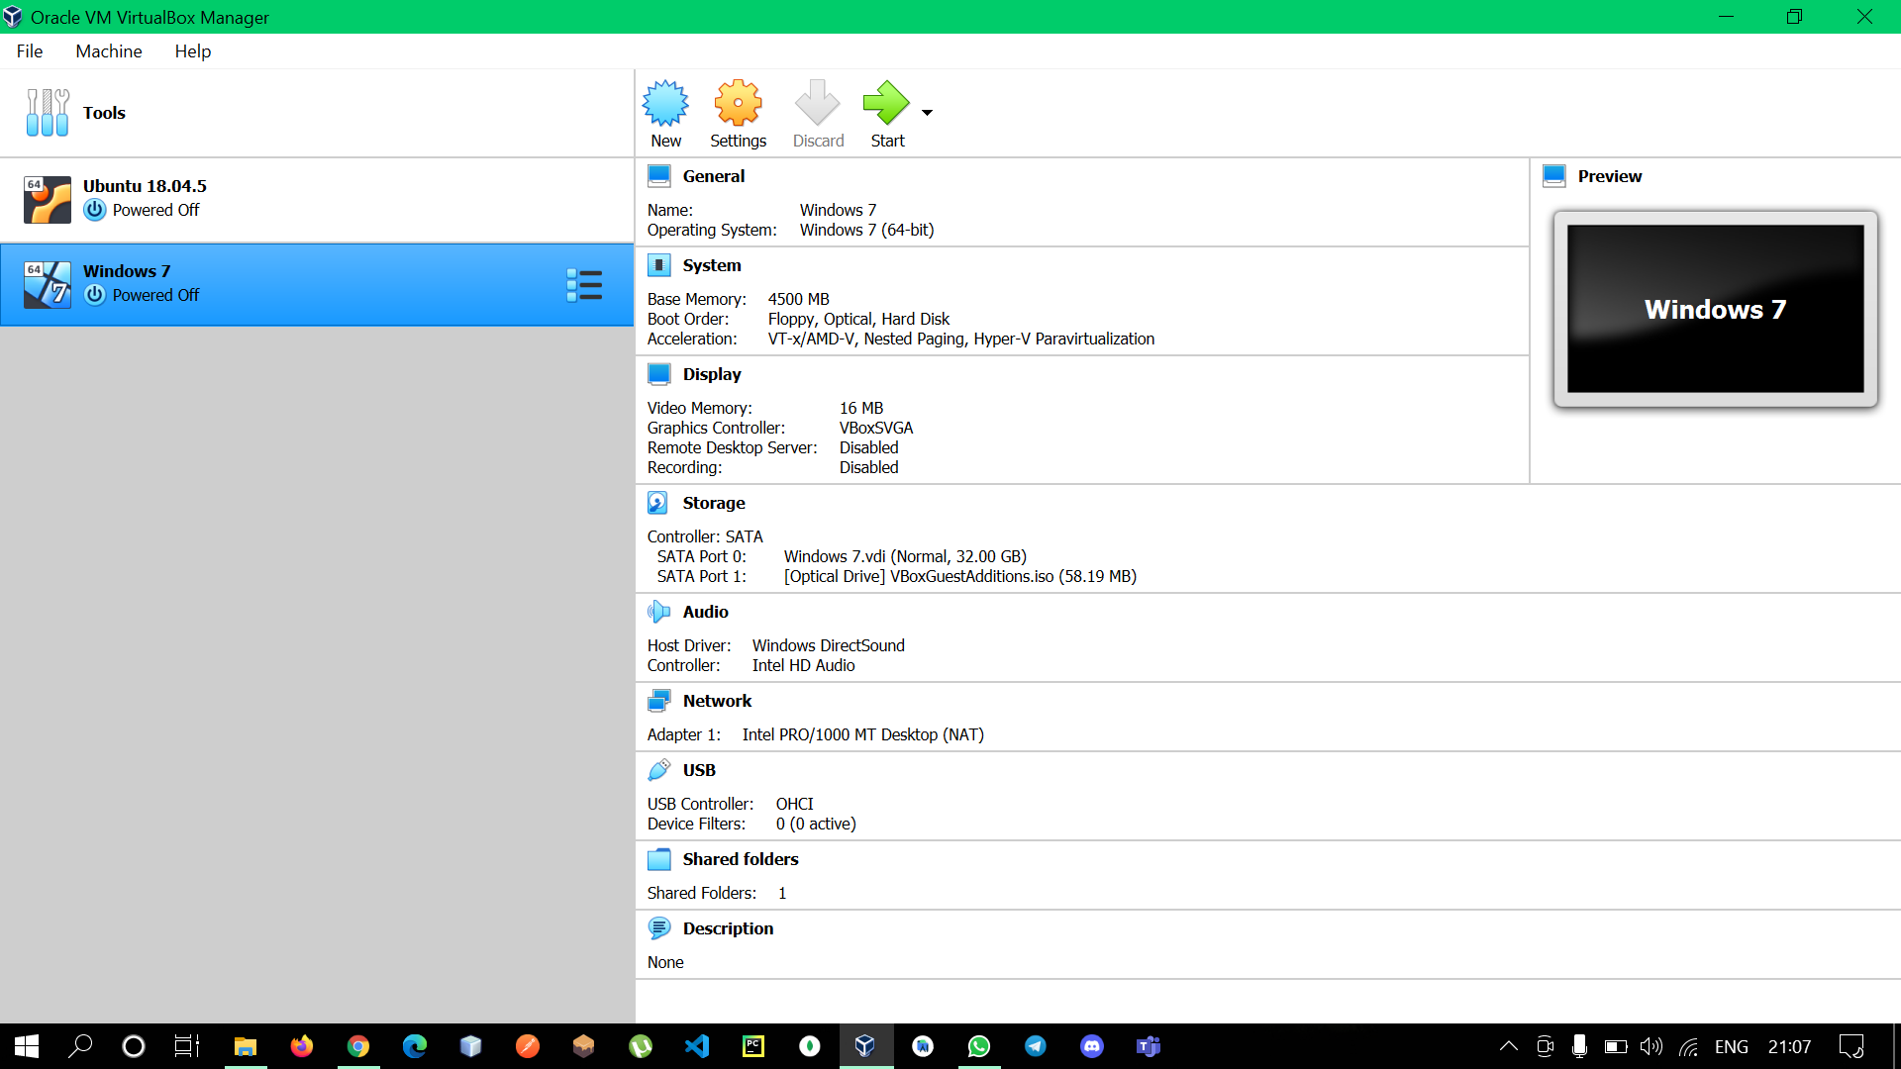

1. **File Transfer**
   1. **Creating Shared Folder in Windows 7**

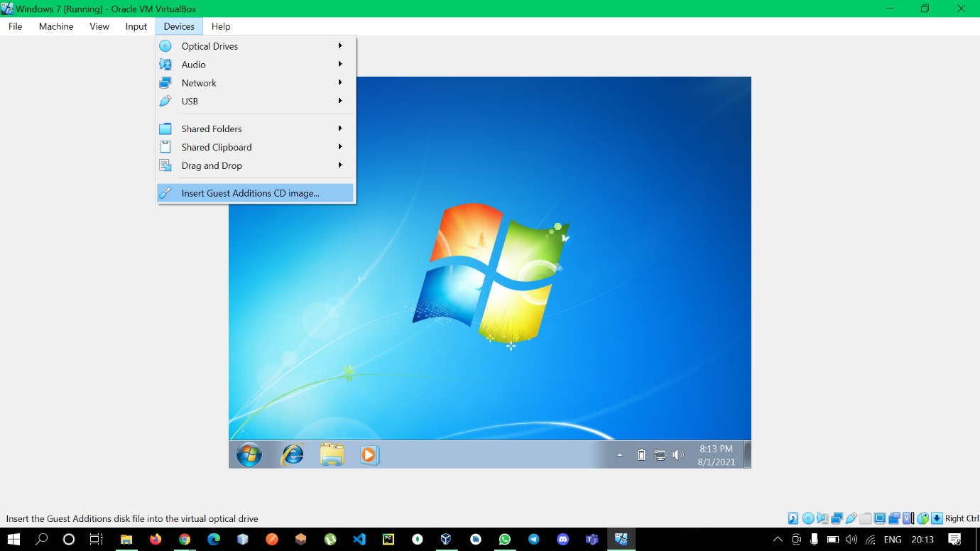 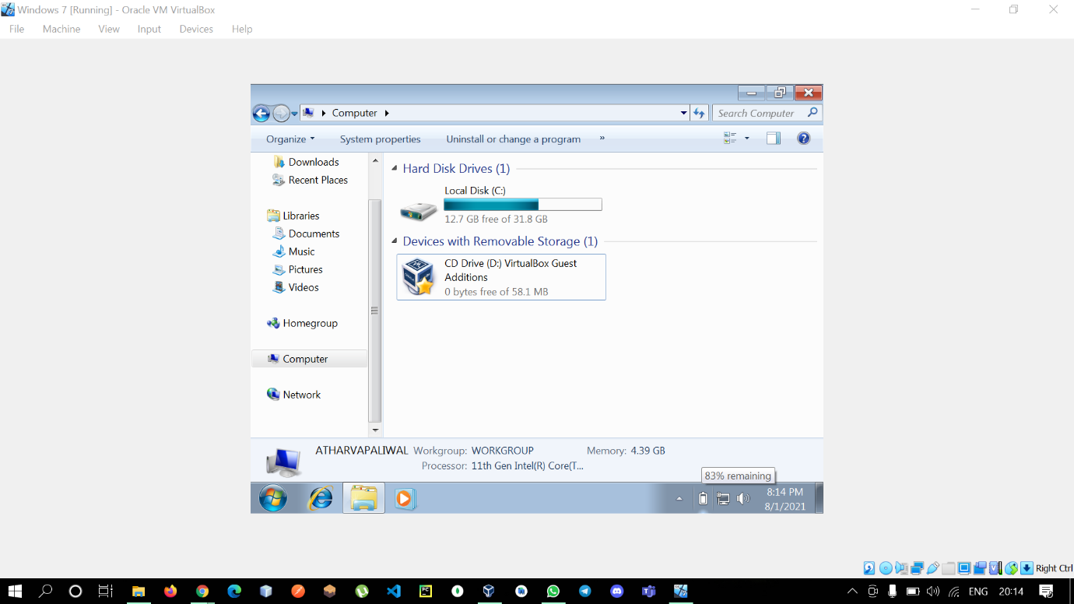 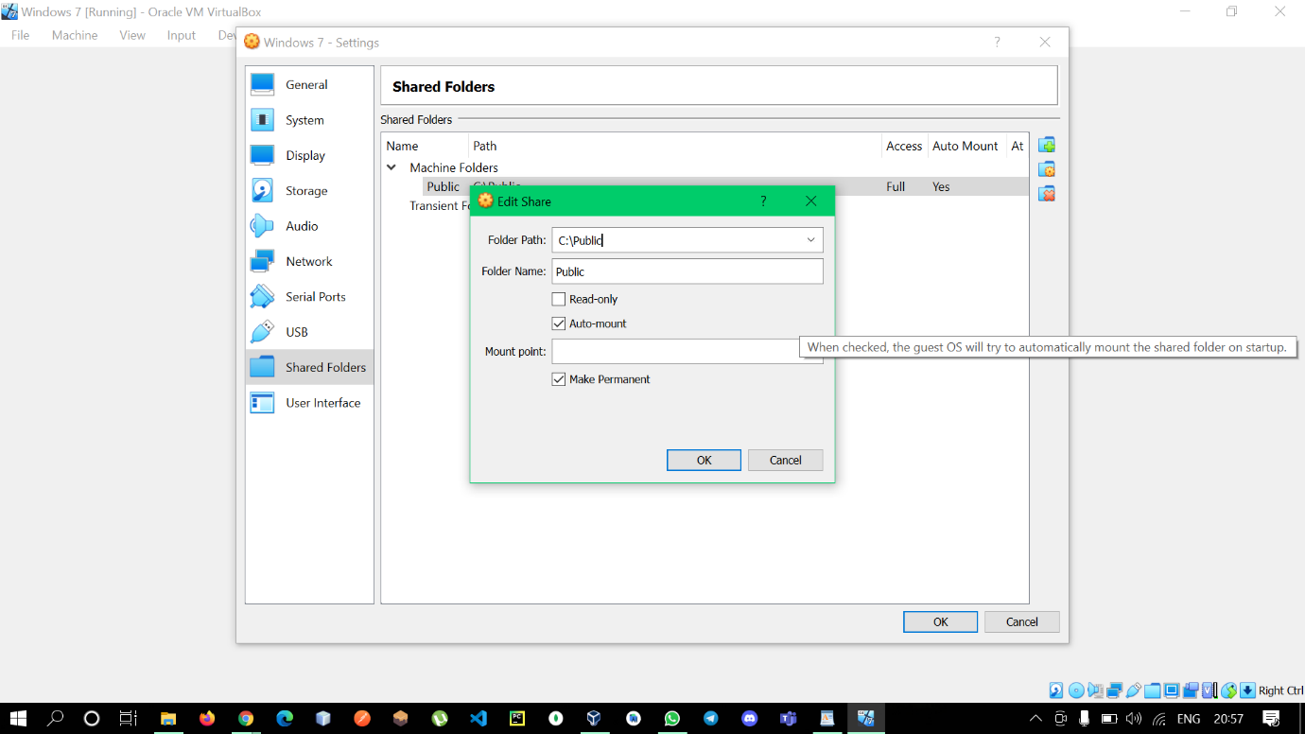 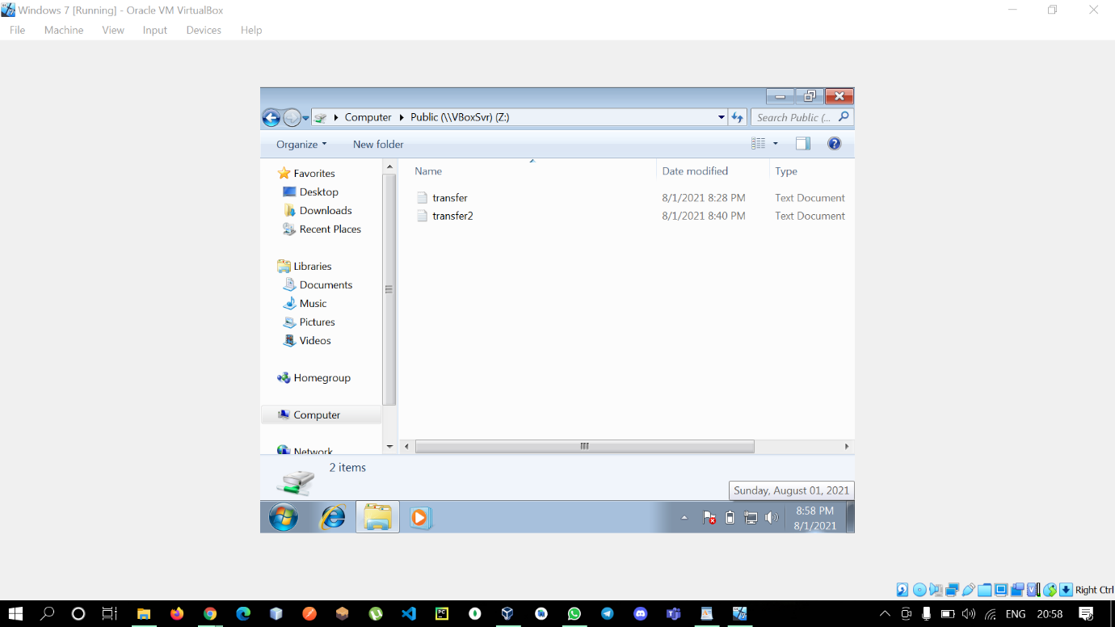

* 1. **Creating Shared Folder in Ubuntu**

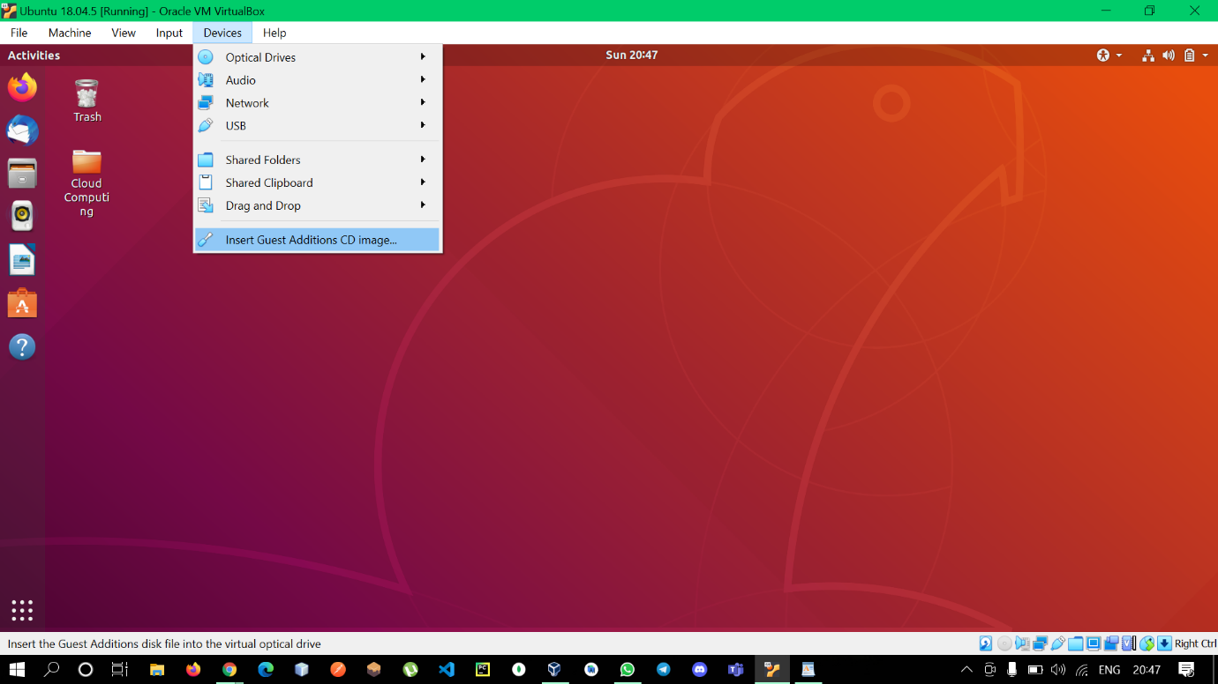

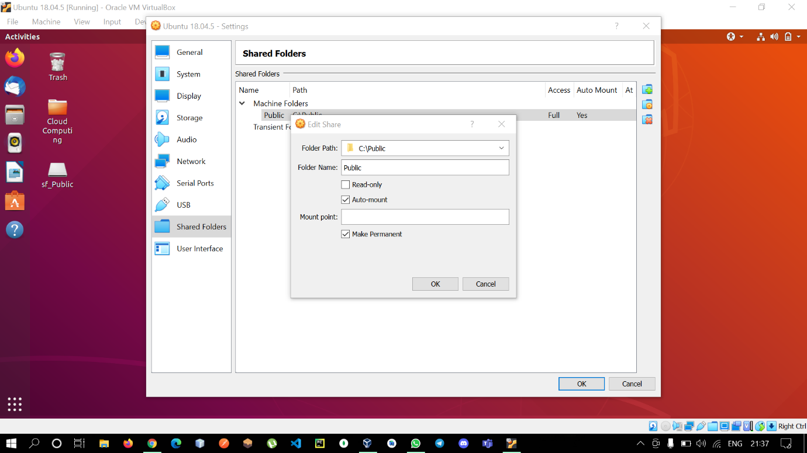

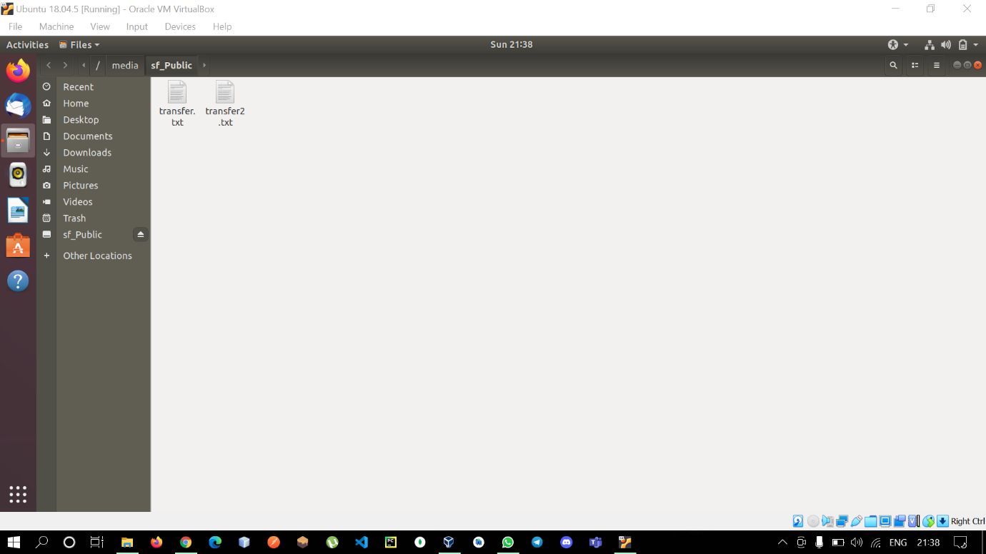

**Conclusion:** Hence a virtual machine of different configuration was created and file was transferred between the two VMs.

**\*\*\* END \*\*\***